Root Cause Analysis Cheat Sheet - Operations
What is Root Cause Analysis?
Root cause analysis is a method for finding out the real reason a problem happened—so you fix the cause, not just the symptoms. Two popular tools are the 5 Whys and the Fishbone (Ishikawa) diagram.
How to use this sheet:
1. Start with a problem statement (e.g. 'Missed delivery deadline').
2. Use the 5 Whys table to dig deeper into the causes by asking 'Why?' five times.
3. Use the Fishbone table to brainstorm possible causes in different categories.
The 5 Whys Table:
Level | Answer
Why #1
Why #2
Why #3
Why #4
Why #5
The Fishbone Diagram Table:
Category | Possible Causes
People
Process
Equipment
Materials
Environment
Management
Tip: After filling out these tables, look for causes that show up in both—the root cause is usually where problems overlap.
Use this diagram by creating something with ‘SmartArt’ on Word or with textboxes, be creative and unique with your design to ensure that you pop out.
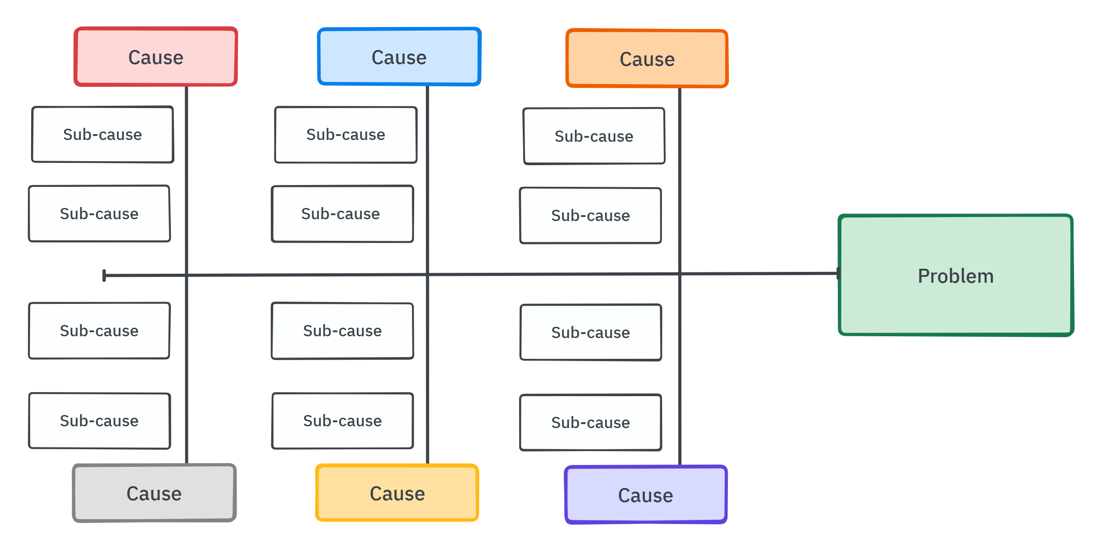
Praburam Srinivasan – fishbone diagram
Growth Marketing Manager

